Meet Your Hosts

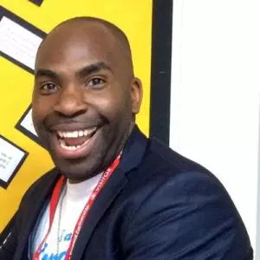 | @ActionJackson  Jackson Ogunyemi is the founder of @TheFixUpTeam, working with great minds to transform our students into champions. He founded the company to empower students to take control of their exams, revision and well-being; this is where he developed his passion for speaking. He is a lover of cheesecake, running and inspiring everyone and is here to get us all feeling excited about #TMLondon!

@ASTSupportAAli  Amjad Ali is an assistant headteacher in charge of Inclusion at a large secondary school in Oxford. He is the creator and curator of a free online toolkit of teaching and learning resources and ideas, offering general inspiration for all types of educators. He also loves TeachMeets! Visit his blog: www.cheneyagilitytoolkit.blogspot.com | 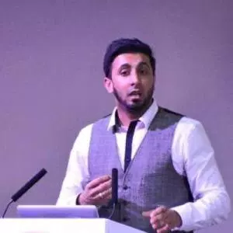

@BennieKara
Bansi Kara is an assistant headteacher with a passion for teaching and learning. She is a @TeachFirst ambassador and blogs / tweets opinions on education, equality, literature, language and society. Bansi works tirelessly as an @SLTchat host and has recently raised the profile of @WomenEd, an important agenda in the educational sphere. She writes a thoughtful blog at www.EdStatesWoman.wordpress.com

@DiLeed
Di has been working in schools since 1984 and has worn a lot of different hats but most of them have been to do with English, Literacy and EAL. Apart from freelance work for The EAL Academy and others, she volunteers with LATE, NALDIC and Sutton Black History Group. Di is an enthusiastic recent convert to social media for networking and signal boosting issues like social equity, EAL and multilingualism - but regrets the 21C requirement for mug shots. If she wasn’t a teacher she would be The Ancient Mariner. https://flexilingual.wordpress.com
Meet Your Hosts

@ICTEvagelist  Mark Anderson is @ICTEvangelist; a former assistant headteacher with more than 20 years teaching experience in schools. This is the 32nd TeachMeet he’s organised. Mark now works with schools and speaks at conferences sharing his ideas and vision all over the world. Mark is also a best-selling author and award-winning blogger of http://ictevangelist.com and is ranked as the most influential edtech person in Europe.  If he wasn't a teacher, he'd probably be a Methodist minister. | 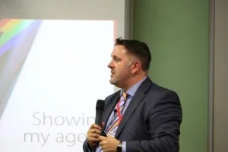

@iTeachRE
Andy teaches RE while trying to survive being head of year 11. He references Bruce Springsteen in many of his lessons and has met Pope Francis. Andy hates "bad RE" and has recently written a new GCSE textbook (filled with "good RE"). While often found defending Catholic education, he has no qualms with making crunch tackles on the Anglican vicars who join in with staff 5-a-side football! Andy got a litre of gin in the Secret Santa; his colleagues know him well.
Visit his blog: www.MrLewisRE.co.uk If he wasn't a teacher, he'd probably be a cowboy.

@ICTMagic
Martin is a Primary teacher from Essex and part of the UKEdChat.com team. He is a sharer of edtech and editor of UKEd Magazine. Martin has perfected his 'teacher stare' since 2000 in both the UK and China, and stands by his record of inspiring more children than he scares. Wherever papier mâché remains un-glittered, full stops are absent, or something needs fixing by turning it off and on again... he’ll be there.
If he wasn't a teacher, he'd probably be sleeping and less of a stranger to his family!

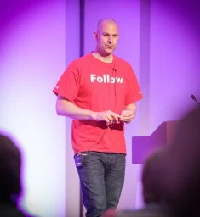 | @TeacherToolkit  Ross McGill has been teaching since he was 18 years-old and is a design technology teacher. Online he is better known as @TeacherToolkit, the ‘most followed teacher on Twitter in the UK’. He is an award-winning teacher and deputy headteacher, who writes the ‘most influential blog on education in the UK’ and one of the most widely read across the world! In 2015, Debretts listed him as one of the ‘500 Most Influential People in the Britain’. Teacher Toolkit is also ranked one of the ‘top-100 brands in education-technology’ by Onalytica. .

