Assignment 2: Action Research Project
Pose, Pause, Pounce, Bounce An Assessment for Learning Questioning Technique
Abstract
This Action Research Project was carried out over a three week period with a year 7 class during their mathematics lessons, using the Assessment for Learning questioning technique ‘Pose, Pause, Pounce, Bounce’ to discover whether it could be used to tease out pupil understanding and promote higher order thinking and responses.
Since questioning is an important element of every teacher’s skill set, it is through careful questioning that they can impact their student’s learning and develop their thinking. The technique aims to move away from lower order questioning of a single pupil, to posing higher order questions that involve many pupils in deeper thinking and the development of a response. The technique offers a means to take questioning from good to outstanding by OFSTED’s standards.
My research demonstrated that the technique did facilitate the promotion of higher order detailed responses from a range of pupils, encouraging contributions from all pupils including those often either unable or reluctant to answer. It teased out understanding and misconceptions, the questioning process was engaging, interactive and at times lively and was an element of the lesson that the pupils readily took part in and one of its most valuable parts. As a result there were far less pupils claiming to not know the answer, less blank faces and more engagement and contribution from the class as a whole.
The implications for my own practice and that of the school in which this research was carried out in, involve utilising this technique as an effective framework for questioning. It is simple and effective and when used in well timed periods of the lesson it can facilitate higher order and more in depth pupil responses. It is a technique that can be developed and perfected without the need for extensive training or resources outside the requirements of normal teaching and therefore it can be simply integrated in to any teachers repertoire.
Introduction
Socrates defined teaching as ‘the art of asking questions’ and figures suggest teachers ask on average 400 questions per day, which “accounts for up to one third of all teaching time.” Hastings (2006:67). Effective questioning is particularly interesting to me and is fundamental to my development as a successful Mathematics teacher.

During a school INSET day, designed around questioning I encountered an appealing strategy for effective questioning which seemed simple to implement with reported significant benefits. Further investigation revealed an alignment with the Maths department’s Development Plan and this became the focus of my project. This Assessment for Learning questioning technique named ‘Pose, Pause, Pounce, Bounce’ is used to tease out pupils’ understanding and promote higher order thinking and responses from all. The technique is a repackaging of elements of academic research that include Mary Budd Rowe’s 1986 work on wait time, Jeremy Hodgen and Professor Dylan Wiliam’s 2006 Assessment for Learning and Socratic questioning methods of drawing answers out of pupils.

The ‘Pose, Pause, Pounce, Bounce’ technique structures questioning in to four key stages to ensure that pupils have thinking time, that a range of pupils are selected and that pupils work together collaboratively rather than competitively exploring ideas and building on each others responses. It aims to aim enable teachers to explore pupils’ ideas, to tease out understanding and develop higher order thinking. It aims to differentiate learning experiences for pupils and move away from closed questioning.

In this Action Research project I will discuss the technique and explain the approach I used to test and integrate it into my teaching practice. I will seek to explain the extent of the impact the technique had in terms of facilitating pupils to develop their ideas and tease out their responses to develop mathematical thinking and understanding.

The project was carried out over a three week period at a mainstream state secondary school with a class of year 7 middle ability set pupils during their mathematics lessons. Ted Wragg’s 1993 research in primary schools found “only 8 percent of questions were of a higher order nature.” Therefore since these pupils have very recently arrived from the primary environment and may not be used to answering the higher order questions posed to them, they may need to develop their own thinking and confidence to answer these questions. With this is mind I decided to carry out the research with a class in which the pupils seemed most reluctant to answer questions and struggled to articulate their thoughts and responses.

I timed launching the technique with introducing the topic of Algebra, an area of mathematics notoriously littered with misconceptions, unease and misunderstanding, to test if it could assist with the thinking and understanding required by the topic.

I shall seek to answer the question: Does the AfL questioning technique ‘Pose, Pause, Pounce, Bounce’ tease out pupil understanding and promote higher order thinking and responses?

Although I shall be collecting data which I will seek to analyse, the research is with just one class over a short period of time so much of the analysis will be qualitative reflection rather than statistical analysis. I will reflect on the results in terms of their implications going forward with my own teaching practice and that of the Maths department with respect to their development plan.

Literature Review
The AfL technique ‘Pose, Pause, Pounce, Bounce’ or PPPB is presented as a means to take teachers’ questioning from good to outstanding in terms of OFSTED’s judgment. “The best questioning probed pupils’ knowledge and understanding, with follow-up questions that helped pupils to explain their thinking in depth and refine initial ideas.” Ofsted (2012:35).

Current information on PPPB can be found on the internet including newpapers (The Guardian, 2013) and appearing on The Times Educational Suppliment (2012) in the form of a PowerPoint presentation. As yet there is no specific PPPB academic researching, however there is much research within the key techniques that underpin each stage. Pose: higher order questioning. Pause: wait time. Pounce: hands down and random pupil selection. Bounce: involving muliple pupils.

Pose
Teachers ask both lower and higher order questions for different reasons, the PPPB technique aims promote higher order responses, so lets start by defining these. “Lower-order questions require children to remember, and higher order questions require them to think. As a general rule, lower-order factual recall questions tend to be closed with a single right answer … Higher order tend to be open – with a range of possible responses.” Hastings (2006:68). Higher order thinking is triggered when a pupil is faced with an unfamiliar problem and it involves the application of logical, reflective and creative thinking skills.

Pause
The next stage of the technique rests on insisting on silence and holding the pause however uncomfortable. “The silence seems interminable, and both instructor and students know that the power to end the pain lies with the instructor who created it to begin with.” (Allen, 2002). This stage is essential to the success of the technique and draws on Mary Budd Rowe’s 1986 research findings, that increasing the wait time improved the number and quality of response. “For lower order recall, three seconds was the optimum wait time, while more than 10 seconds produced even better results with higher order questions”. Her research also found that extending the wait time between the pupil giving the answer and the teacher commenting on it allows pupils to revise or develop their response and encourages other pupils to contribute.

When students are given 3 or more seconds of undisturbed "wait-time" Rowe discovered that the correctness of responses increased, there were less ‘I don’t know’ responses. The impact this had on the teacher was that they decreased the quantity and increased the quality of responses, and they asked questions that required more complex information processing and higher-level thinking on the part of students. Stahl (1994) who preferred to refer to ‘wait time’ as ‘thinking time’ drew on Rowe’s research explaining that, it is not that anything less than three seconds thinking time is bad and more than three is good it is about the pupils’ threshold. He explained since 3 seconds is this is the threshold for most students to develop their responses, it is then “the teacher's job is to manage and guide what occurs prior to and immediately following each period of silence so that the processing that needs to occur is completed.”

Other sources suggest that there is an optimum wait time required to “ensure the smooth flow of the lesson and avoid embarrassing silences, but also allow pupils enough time to think through their answers.” The time that most teachers chose is seven seconds because “waiting much longer than this may lead to other pupils becoming restless.” (Muijs 2011:59).

Pounce
The pupil that the teacher selects to pounce on after the thinking period could shape the final outcome of the response, shyness, lack of confidence or bad previous experiences can result in some pupils feeling reluctant to contribute. “A non-evaluative positive atmosphere is important. Pupils are more likely to get involved if they feel a wrong response will not elicit criticism or ridicule from the teacher (or fellow pupils).” (Muijs 2011:55) This atmosphere is essential if all pupils are to have an equal chance to develop their thinking.

Since pupils are responsive to their teacher’s reactions, Harrison (2009) explains that it is important not to pass judgement too soon and that waiting “before they start correcting and curbing the direction of the discussion allows for greater child interaction and thoughtful reflection.”

Bounce
The teacher is assisted by the bounce phase since it prevents the teacher immediately reacting to each of the student’s answers and passes the opportunity to the students to evaluate “whether the answer is correct, voicing more of the student talk and ideas.” (Harrison, 2009:15).

Professor Dylan Wiliam supports pupil’s development of others responses as positive step away from what he calls Initiation, Response, Evaluation closed questioning, he believes the “Key to the success of both peer and self-assessment is talking about mathematics, as this provides students with ways of thinking about mathematical concepts.” Hodgen & Wiliam (2006:21).

McGill (2011) summarises his article suggesting we ensure teachers take the time to work with pupils to tease out understanding since this is “far more important than moving onto the next page in the lesson. That’s what learning is about.”

Methodology
The selection of my data collection method was based on minimising interruption to lessons by collecting data discreetly so the pupils did not feel that their responses were being gathered for scrutiny. This could have affected the integrity of the research since the strategy requires pupils to feel comfortable to provide responses without judgment. Therefore the class teacher who usually sits observing and making notes at the back on the classroom subtly collected the data for my research.
Pupils did not complete formal questionnaires with closed questions since this did not align with the research topic. Instead, during my research and at the end of the three weeks I asked the pupils as a group for their feedback to evaluate how they felt the questioning method was working for them.
To establish the data that I needed to collect and the method that I would use, I examined the aims and elements of PPPB and designed the data collection tally sheets in appendix 1 to enable me to collect the same type of information for each question asked. The PPPB strategy is based around asking open questions, giving thinking time and involving more than one pupil with the aim to draw out high order responses so these attributes appear on the collection sheet.
I designed the sheet for intuitive completion following the PPPB sequence stages with a seating plan below the data collection table to record the distribution of questions and track their paths around the classroom, since I also wished to record and examine the distribution of questions and particular pupil’s involvement.
The possible ethical issues related to this research were focused around any disturbance caused to lesson progress. However since the technique is aligned with the departments Development Plan it was deemed to fall within the remit of normal teaching practice.
I planned to implement it with minimum disruption and without removing pupils from lessons, they were not filmed or recorded, any issue concerning pupil identity was resolved by changed the names of the pupils in this document.
Choosing to carry out the research with one class instead of another brings issues of denying that benefit elsewhere, I selected the class in greatest need of developing their responses and counterbalanced this issue by gradually integrating the PPPB technique in my teaching of other classes.
I planned to collect data for two, 1 hour lessons per week over a three week period with baseline data collected as a reference point before any changes were made to my practice as follows:
Week 1: Baseline and introduction of PPPB questioning with mascot.
Week 2: Random pupil selection to pounce on with mascot.
Week 3: Integration of PPPB into lesson with various pupil selection and removal of mascot.

Since the success of this technique relies on pupil’s contributions, I planned to present to the class a detailed breakdown of how the strategy works including using this cartoon and modeling the process.
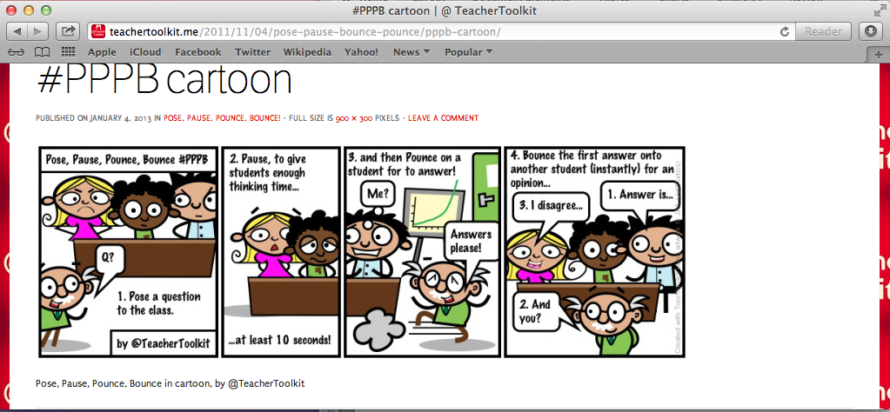
Figure 1 : Cartoon taken from the TeacherToolKit (2013).

To symbolise the questions being bounced from pupil to pupil I decided I would introduce a soft toy called the Question Mascot as a visual cue, which could be passed to the first pupil I pounced on then passed around the class from pupil to pupil to map out the question’s path. The pupil in possession of the mascot being the only one allowed to speak to avoid the issue of pupils shouting out.

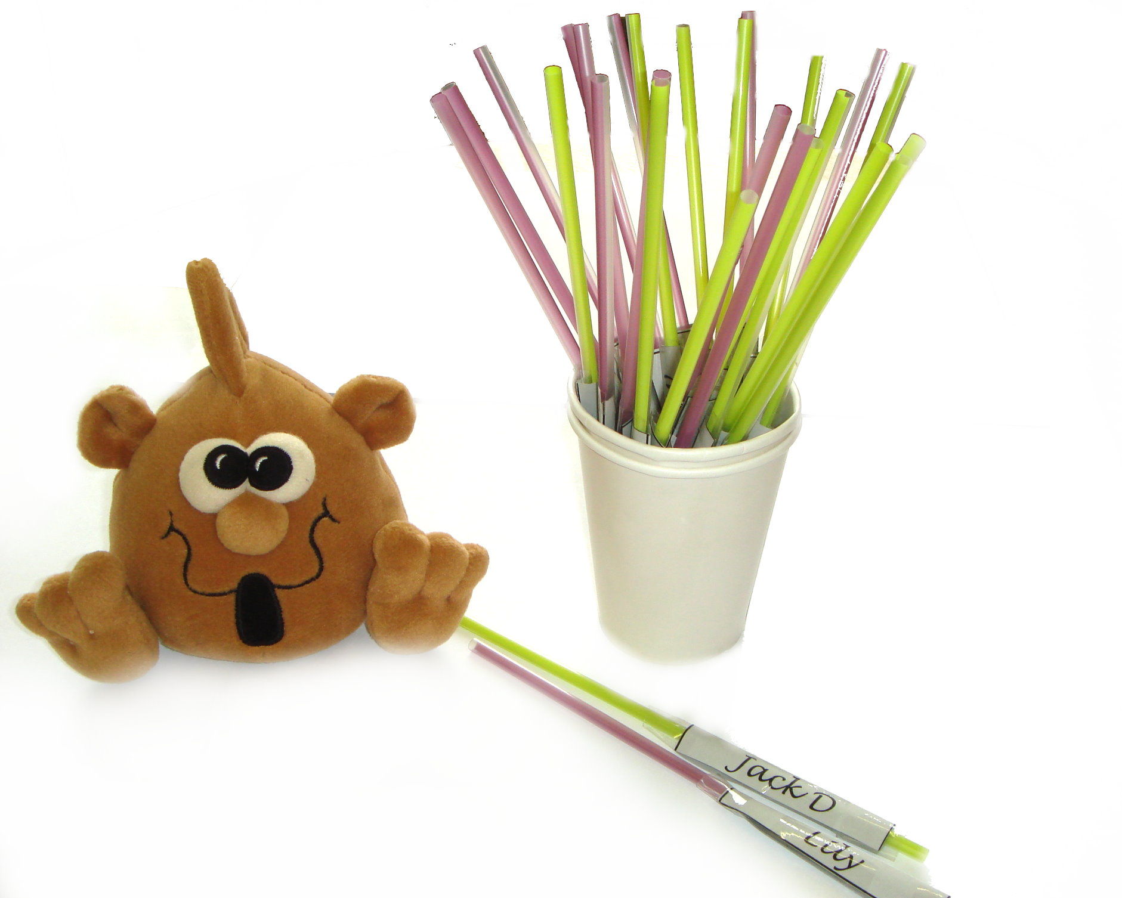

Figure 2: ’Question’ Mascot and cup of name straws used for pupil selection.

Additionally the process requires pupils to be ready to provide an answer at all times, so I explained I would be also be selecting some pupils at random using a pot of straws with each other their names written on so the pupils did not know who would be selected, but all needed to be ready to answer.
Posing open questions is difficult to do on the spot, so I prepared the questions in advance of the lesson using Watson’s glossary of prompts for mathematical thinking (1998) and Bloom’s Taxonomy (1956) for the language and design of the questions involving evaluation, synthesis and analysis. Examples of probing questions for algebra were taken from the DfE National Strategy for Assessing Pupil Progress (2009) and designed to present pupils with the opportunity to consider multiple answers with layered questions.
Since this is an action research project, I will explore the links between the actions that I take and how these impact my research outcomes in a cycle of planning, action, observation and reflection as figure 3. Trialing the technique in the first lesson will guide me to consider and explore the changes and developments that I will need to make over the course of the three weeks in order to evolve the strategy and make improvements to my practice. I am approaching the research phase mindful of the ongoing reflection process that will be required throughout and in to my onward practice.

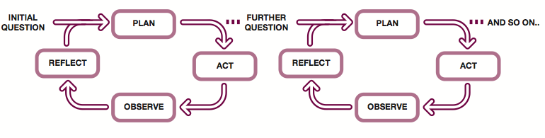

Figure 3 : Action Research Four Phase Cycle from The Open University (2005:5)

Findings
I will examine key aspects of the data collected and discuss this in terms of Pause time, the number of pupils involved in the responses and the proportion of higher order responses received. The volume of data collected is not sufficient to perform a statistical analysis, a much more in depth study of a range of year groups, topics and schools would be required to provide reliable statistical data. The graphs are for illustrative purposes and to provide a reference for my discussion later which provides more of an overview and reflection on my research study.
It is important to note that the amount of data collected for lessons 1, 2 and 3 was for approximately 30 questions that were asked in the lesson, however for lessons 4, 5 and 6 it was at approximately 5 questions since the PPPB questioning was limited to a particular section of the lesson.

Open or Closed Questions

Figure 4 : Proportion of open and closed questions.

In the baseline first lesson 58% of the questions I asked were open and this figure did not change for lesson 2 when the PPPB technique was first introduced. In the third lesson over 70% of questions asked were open and this figure rose further in the lessons that followed. In lessons 4, 5 and 6 there were far fewer questions posed but most of them were open, the closed question portion of the bar represents a single question in most cases.

Pause Time

Figure 5 : The pause time recorded before the first pupil’s response.
This chart shows that the dramatic increase in the proportion of questions that pupils had more than 10 second thinking time for as the weeks went on. In the baseline lesson pupils only had thinking opportunities over 10 seconds for a few questions. By lesson 4 the majority of the questions asked were given over 10 seconds wait time. Here it is important to note that in later lessons the data was collected for a smaller, targeted number of questions that were part of a pre-planned section of the lesson, either the introduction or plenary rather than looking at the lesson in its entirety.

Level of Pupils Involvement
The number of pupils involved in developing the responses is explored here in two different ways. The graph below shows a dramatic increase in the mean average number of pupils that responded to each question upon introduction of the PPPB technique, compared to just one pupil per question in the baseline lesson. Here we must remember in earlier lessons every question posed was recorded, in the later lessons we have data for only five specific, pre-planned questions, so we can see this will effect the results since these key questions were designed specifically to engage multiple pupils.

Figure 6 : Mean average number of pupil responses per question.

Figure 7 : The number of pupils involved in responded to a question sample.
Here we compare a snapshot sample of five questions posed instead of looking at an average for the whole lesson, it can clearly be seen that in the earlier lessons just one pupil provided a response to each question, and when the PPPB was targeted it included up to as many as seven pupils.

Figure 8 : A comparison between the wait time and the order of pupils’ responses.

Lower and Higher Order Thinking
Figure 8 can be used to examine the relationship between wait time and the order of the pupils’ responses, whether higher or lower order. In the baseline lesson 1 the majority of questions had less than 10 seconds wait time with 60% at less than 1 second, and there was a fairly even split between higher and lower order responses. The second and third lessons have a similar volume of wait times in each category; here the data was recorded throughout the lesson for approximately 30 questions. We start to see from lesson 4 onwards the green bars that represent over 10 seconds wait time, and higher order responses are prominent. This shows that with a greater percentage of wait time there is a greater percentage of higher order pupil response. We could interpret this as a connection between a longer wait time giving rise to higher order responses, and in the earlier lessons a shorter wait time produces lower volume of high order responses. On balance we must remember that in the later lessons there were far less questions, they were preplanned and designed to be higher order and demand a longer wait time before the first response is given.

The effect of the action research cycle on the data collected
Whilst I was carrying out my action research, I made changes to my teaching practice and the way that I used the PPPB questioning technique as the three week research period progressed. This resulted in a variation in the volume of data collected at each stage and this has had an impact on the way that the data has been presented on the charts in this section.
I planned to collect data for every question I asked when I was addressing the whole class. For the first two lessons there were a large number of questions and data collected. I gradually introduced strategies for selecting pupils since many were still raising their hands and others were reluctant to answer when I pounced a question on them and the use of name straws to select pupils at random was one of these strategies. I found that the PPPB questioning technique was very involved and time consuming and so adapted the technique by focusing the points at which I used it. This meant that far less data was collected in subsequent lessons and it has made it difficult to make comparisons between the data collected during earlier lessons.
The plan, act, observe and reflect cycle was used constantly over the three week period, and Table 1 summarises the questioning approach for each of the lessons including the resources used and the duration of the PPPB questioning. The progression and development in my practice can be seen, moving from questioning in whole lessons to targeted sections in order to keep the pace of the lesson, keep pupils engaged and to prevent the questioning consuming too much of the lesson. I found that the pupils enjoyed passing the mascot around the classroom and they were empowered to select pupils instead of expecting the teacher to do this, so I also found this aspect of the technique an interesting development. Since the mascot was facilitating empowering the pupils to select their peers, it was required to be used for longer than I had planned and so I only withdrew the mascot at the end of the final lesson to test if the class were able to pass the questions around the class without a physical prompt. They were able to complete this successfully and this drew my research period to a close.

Week | Lesson | Questioning Approach | Resources | Duration
1 | 1 | Usual questioning style with no changes made to practice, this will be the baseline. | None | Throughout the lesson
 | 2 | Teacher driven selection of pupils for Pose, Pause, Pounce, Bounce questioning (no hands up) explain to pupils PPPB will be used. | Mascot | Throughout the lesson
2 | 3 | Use name sticks to select pupils for all questioning using the mascot for Pose, Pause, Pounce, Bounce questioning. | Mascot, name straws | During introduction and whole class intervention
 | 4 | Use combination of hands up, teacher selection and name sticks to select pupil to Pounce on with question and empower pupils to bounce question by passing the mascot around the class. | Mascot, name straws | Target 10 minute plenary
3 | 5 | Use a combination of hands up, teacher selection and name sticks to select pupil to Pounce on with question allowing a natural discussion to move around the classroom, with or without the mascot. | Mascot, name straws | Target 10 minute introduction
 | 6 | Remove the passing on of the physical mascot and pose questions naturally asking pupils to think for 10 seconds before answering and allowing a natural discussion to move around the classroom | None | Target 10 minute plenary
Table 1: The schedule of questioning approaches for the three week period
Discussion
Data analysis is useful for exploring connections such as that between the lessons in which the pupils’ thinking time was longer and the volume of higher order responses that were developed. This quantitative data is helpful to illustrate the effects of the PPPB questioning strategy, however it was in listening to the actual responses provided by the pupils and being part of the process of exploring their understanding that the true extent of the effectiveness of the strategy was witnessed.
What the data analysis does not show are the qualitative findings of my action research, the quality of the in depth responses, the level of understanding and teasing out of misconceptions that the PPPB technique facilitated. The year 7 pupils clearly explained and articulated key differences between sets of expressions and explored how they would create a formula using some key pieces of information.
The questions posed that produced the best responses were those that had been pre-prepared involving the use of language Bloom’s Taxonomy to encourage pupils to use it to evaluate and compare information.
The transformation in the responses that developed in the later lessons compared to those at the start of the project was huge, and indeed as Rowe’s 1986 research suggested, a wait time of over 10 seconds produced the best responses to higher order questions.
Although McGill (2011) suggests teasing out understanding is more important than moving to the next phase of the lesson, there are implications to consider. The technique does require whole class lesson time and can impact a lesson’s pace and lead to some pupils getting frustrated if they are not chosen to speak. Not all pupils reached the same level of understanding at the same time and some pupils were held back waiting for their peers to develop an answer before they can move to the next phase.

Analysis of the spread of questions was interesting, and in the lessons where the PPPB questioning was targeted to just five key questions, roughly 2/3 class were involved in the responses. This forms a clear contrast to just one pupil responding to each other the questions posed in lesson 1 before the PPPB technique was introduced, agreeing with the suggestion that the technique involves a wider range of pupils.

The awkwardness of the silence of the thinking time that was referred to by both Muijs (2011) and (Allen, 2002) was indeed very real and it did take a few lessons before it became easier to tolerate. Since this is fundamental to the success of the technique it is something the teacher will need to be mindful of and persevere with. Knowing that holding this silence is in fact facilitating pupils engaging in deeper thought, makes it more tolerable and hopefully it will eventually become enjoyable for the teacher, it did for me.
This class responded very well to being asked to think in silence and was calm and controlled from the first time that I introduced the technique. A few lessons in, the debate got a lot livelier with pupils keen to have possession of the mascot so they could have their say. Some usually reluctant pupils were keen to contribute their responses, including a particularly succinct and well thought out response from Leticia who rarely speaks out, her little voice perfectly articulating the final summing up of some fundamental algebraic methodology at the end of a bounce chain of responses. Interestingly some pupils that are usually very keen to contribute answers took more of a backseat and reported that they were uncomfortable anaysing other pupils thoughts in case they caused offence. This was not something that I uncovered during my literature review but is however an important consideration when approaching the technique with a class.
Harrison (2009) explains that refraining from passing early judgment encourages pupils to contribute freely, I found that with the questions I tried to completely refrain from passing judgement on, the bounce path was far longer. For those question paths in which I provided a steer, pupils did start to hold back on their contributions supporting Harrison’s theory. The implication of this however is that whilst I would not wish to disturb the development of the response, it was time consuming when large numbers pupils were involved with one question.

PPPB questioning promoted a lively atmosphere of debate and evaluation from all pupils, some particularly interesting findings were with one pupil posing a question that bounced around the classroom back to him allowing him to add the final response in which he answered his own question.
The use of the straws to select pupils and the bouncing mascot really seemed to engage the pupils and facilitate the bedding in of the technique; once the mascot was removed the pupils were still able to follow the process with a more natural flow of responses and class discussion. Although this was a year 7 class, the level of understanding and the articulation of their ideas could have easily been present in a class of much older pupils. The ease with which they were talking through their understanding of the similarities and differences between sets of equations and expressions was impressive and unexpected. Previously reluctant and quiet pupils were happy to provide responses, and some of the usually disruptive pupils used the quiet thinking time to create questions of their own to ask. This is of course requires more in depth anlaysis, however it seemed to enable the more energetic or disruptive pupils to feel the element of empowerment in the being able to impact the path of the discussion and it appeared to engage them positively in the questioning sessions.
Due to the time constraints, it would appear not to be practical to use this questioning technique with every question posed during a lesson. I found that posting fewer higher quality questions in a certain phase of the lesson resulted in increasing the quality of responses supporting Rowe’s findings (1986). A teacher requires a balance of open and closed questions and time constraints will not always allow extended questioning periods. However with careful planning of the key questions and the stages at which it will be used, Pose, Pause, Pounce, Bounce is an extremely effective technique for involving the whole class, getting all your pupils thinking and teasing out their understanding.

Conclusions
A summary of the main findings of my action research were:
- The technique teased out understanding and worked through misconceptions.
- It promoted higher order thinking and responses.
- It encouraged the use of mathematical language.
- Quieter pupils ‘woke up’ and contributed readily.
- There were a minimal amount of ‘I don’t know’ responses.
- A number of pupils were involved in each response.
- Pupils posed their own high order questions.
- Pupils offered a response more readily when they were picked by the fate of the pot of name straws rather than by teacher selection.
- It worked effectively with preplanned questions.
- The technique is best targeted to certain sections of the lesson.
During my research I was able to reflect on and alter my questioning skills and understand the points in the lesson in which the technique could be used effectively. Prolonged questioning periods, although useful for assessing understanding, sometimes consumed lesson time and meant that there was insufficient time for other tasks which was somewhat frustrating. This led me to design ten minute sections of the lessons in which to pose some carefully selected pre-planned questions.
The PPPB technique does tease out understanding and promote higher order thinking and responses in the context of my research. Due to the brief nature of the research and the fact that I carried this out with one class, in one age range and at just one school, it is not possible to say if this is true of the technique in all situations.
However I did use the technique with other classes and pupils understood and respected the quiet thinking time and evaluation of others responses. Pupils were still keen to raise their hands and share their responses and some were quite disappointed when I did not ask them to, but enjoyed the anticipation of whether their name straw would be selected. Pupil feedback was generally positive, however the usually vocal students were aware they were not answering as many questions as usual and appeared restless. Typically quieter pupils, and reluctant contributors reported that they had enjoyed the chance to contribute and felt more confident with building a response as a group rather than responding when they were asked a question individually.
In conclusion, whether or not PPPB takes questioning from good to outstanding by OFSTED’s standards is for them to judge, however it is indeed an effective technique for developing higher order responses and is especially powerful used alongside topics with common misconceptions. It worked most successfully and efficiently with preplanned questions and when specific sections of the lesson were targeted.
The implications for my own practice and that of the school in which this research was carried out, are to use this technique as an effective framework for questioning. The level of understanding that it teased out with my year 7 algebra class exceeded all expectations and it is certainly a technique that I wish to continue to use in my daily teaching practice.

References

Books and Journals

Allen, D and Tanner, K. (2002). Approaches in Cell Biology Teaching. PMC118377

Bloom, B. S. et al. (1956). Taxonomy of Educational Objectives, the classification of educational goals – Handbook I: Cognitive Domain. New York: McKay.

Hastings, S. (2006). The Complete Classroom: Issues and Solutions for Teachers. London: Routledge.

Hodgen, J, and Wiliam, D. (2006). Mathematics inside the black box: Assessment for learning in the mathematics classroom. London: nfer Nelson.

Mujis, D. & Reynolds, D. (2011). Effective teaching (3rd Ed). London: SAGE.
Rowe, M, B. (1986). Wait Time: Slowing Down May Be a Way of Speeding UP!. Vol. 37, 1: 43-50.

Stahl, Robert J. (1994). Using "Think-Time" and "Wait-Time" Skillfully in the Classroom (ERIC Digest No. 12). Retrieved from ERIC database. (ED370885).

Watson, A. (1998). Questions and prompts for mathematical thinking. Derby: Association of Teachers of Mathematics.

Wragg, E.C. 1(993). Questioning in the Primary School. London: Routledge.

Brochures

Department for Education (2009). The National Strategies Secondary. Assessing Pupils’ Progress, Focused Assessment Materials: Level 5. Ref: 00201-2009PDF-EN-02. Crown copyright.

Office for Standards in Education (2012). Mathematics: made to measure. 2012 Report Ref: 110159 London: Ofsted.

Internet Newspaper References

McGill, R, M.(2011) How to move your lessons from good to outstanding: The Guardian http://www.guardian.co.uk/teacher-network/2011/nov/17/lessons-good-to-outstanding-afl-questioning. Retrived 01.02.13 from source.

Internet References

TeacherToolKit (2013). Pose, Pause, Pounce, Bounce.
http://teachertoolkit.me/2013/01/04/pppb-version2/. Retrived 01.02.13 from source.

The Open University (2005). Action Research A Guide for Associate Lecturers COBE. http://www.open.ac.uk/cobe/docs/AR-Guide-final.pdf.Retrieved 05.02.13 from source.

Times Educational Suppliment. (2012) Pose, Pause, Pounce, Bounce. http://www.tes.co.uk/ResourceDetail.aspx?storyCode=6242203.Retrived 05.02.13 from source.

Appendices

Appendix I
PowerPoint used to report findings.

Appendix II
Sample of the data collection sheets used by my observer.

Appendix III
Spreadsheets Containing the Raw Data Collected for Analysis.

