Appendix II
Sample of the data collection sheets used by the observer.
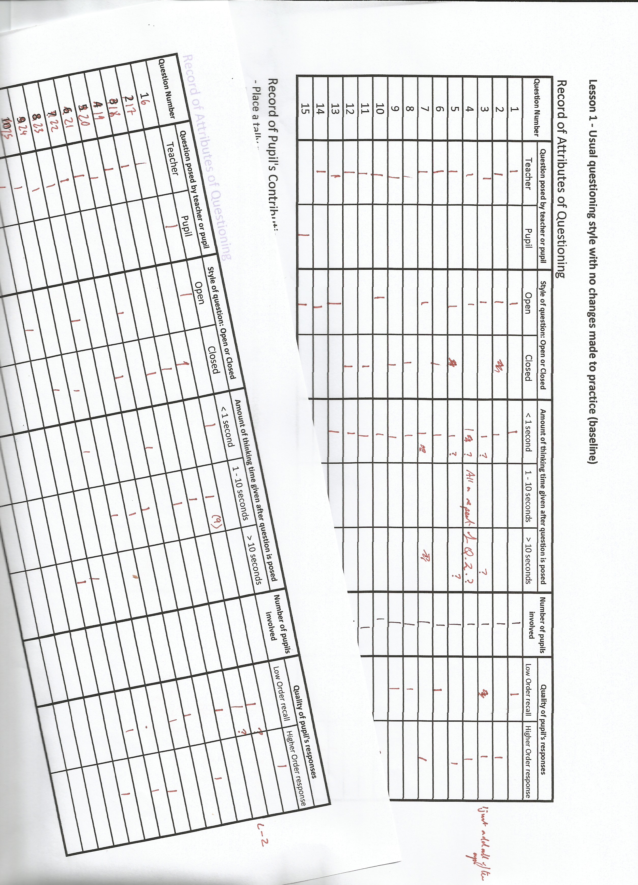

Appendix III
Spreadsheets Containing the Raw Data Collected for Analysis.

WEEK 1 Lesson 1 - Usual questioning style with no changes made to practice (baseline).

Duration: Throughout the lesson

Record of Attributes of Questioning
Question Number | Question posed by teacher or pupil |  | Style of question: Open or Closed |  | Amount of thinking time given after question is posed |  |  |  | Number of pupils involved in the response |  |  | Quality of pupils' responses
 | Teacher | Pupil | Open | Closed | < 1 second | 1 - 10 seconds | > 10 seconds |  |  |  |  | Low Order recall |  | Higher Order response
1 | 1 |  | 1 |  | 1 |  |  |  | 1 |  |  | 1
2 | 1 |  | 1 |  | 1 |  |  |  | 1 |  |  |  |  | 1
3 | 1 |  | 1 |  | 1 |  |  |  | 1 |  |  |  |  | 1
4 | 1 |  | 1 |  | 1 |  |  |  | 1 |  |  |  |  | 1
5 | 1 |  | 1 |  | 1 |  |  |  | 1 |  |  |  |  | 1
6 | 1 |  |  | 1 | 1 |  |  |  | 1 |  |  | 1
7 | 1 |  | 1 |  | 1 |  |  |  | 1 |  |  |  |  | 1
8 | 1 |  |  | 1 | 1 |  |  |  | 1 |  |  | 1
9 | 1 |  |  | 1 | 1 |  |  |  | 1 |  |  | 1
10 | 1 |  | 1 |  | 1 |  |  |  | 1 |  |  |  |  | 1
11 | 1 |  |  | 1 | 1 |  |  |  | 1 |  |  | 1
12 | 1 |  |  | 1 | 1 |  |  |  | 1 |  |  | 1
13 | 1 |  | 1 |  | 1 |  |  |  | 1 |  |  |  |  | 1
14 | 1 |  | 1 |  | 1 |  | 1 |  | 1 |  |  |  |  | 1
15 |  | 1 | 1 |  | 1 |  |  |  | 1 |  |  |  |  | 1
16 |  | 1 | 1 |  | 1 |  |  |  | 1 |  |  |  |  | 1
17 | 1 |  |  | 1 |  | 1 |  |  | 1 |  |  | 1
18 | 1 |  |  | 1 |  | 1 |  |  | 1 |  |  | 1
19 | 1 |  |  | 1 |  | 1 |  |  | 1 |  |  | 1
20 | 1 |  | 1 |  |  |  |  |  | 1 |  |  |  |  | 1
21 | 1 |  |  | 1 |  | 1 |  |  | 1 |  |  | 1
22 | 1 |  | 1 |  |  | 1 |  |  | 1 |  |  | 1
23 | 1 |  | 1 |  |  | 1 |  |  | 1 |  |  |  |  | 1
24 | 1 |  |  | 1 | 1 |  |  |  | 1 |  |  |  |  | 1
25 | 1 |  |  | 1 |  |  | 1 |  | 1 |  |  | 1
26 | 1 |  | 1 |  |  |  | 1 |  | 1 |  |  |  |  | 1
27
28
29
30
Totals | 24 | 2 | 15 | 11 | 17 | 6 | 3 |  | 26 |  |  | 12 |  | 14
Record of Pupil's Contribution to Class Discussion
- Write down the question number that the pupil has provided a response to on the seating plan.

Harry | Sean | David | Sally | Millie | Emma | Katy | Becky
 | 21 | 11 | 7 |  | 26 |  | 2, 6
Rosie | Diane | Michael | Christopher | Maisy | Lee | Catherine | Simon
 | 23 |  |  |  | 14 |  | 3,9,13
Liam | Adam | Sophie | Shelley | Bob | Jason | Leticia
 |  | 10, 12, 25 |  |  | 5, 8, 15, | 1
 |  |  |  |  | 16, 19, 20
 |  |  | Elane | Helena | Jenny
 |  |  |  | 4, 22, 24

WEEK 1 Lesson 2 - Teacher driven selection of pupils and selecting mascot path using Pose, Pause, Pounce, Bounce questioning.

Duration: Throughout the lesson

Record of Attributes of Questioning
Question Number | Question posed by teacher or pupil |  | Style of question: Open or Closed |  | Amount of thinking time given after question is posed |  |  |  |  | Number of pupils involved in the response |  | Quality of pupils' responses
 | Teacher | Pupil | Open | Closed | < 1 second |  |  | 1 - 10 seconds | > 10 seconds |  |  | Low Order recall | Higher Order response
1 | 1 |  | 1 |  | 1 |  |  |  |  | 1 |  |  | 1
2 | 1 |  | 1 |  | 1 |  |  |  |  | 1 |  | 1
3 | 1 |  |  | 1 | 1 |  |  |  |  | 1 |  | 1
4 | 1 |  |  | 1 |  |  |  |  | 1 | 1 |  | 1
5 | 1 |  | 1 |  |  |  |  |  | 1 | 1 |  | 1
6 | 1 |  | 1 |  |  |  |  |  | 1 | 1 |  | 1
7 | 1 |  | 1 |  | 1 |  |  |  |  | 1 |  |  | 1
8 | 1 |  | 1 |  | 1 |  |  |  |  | 1 |  |  | 1
9 | 1 |  | 1 |  |  |  |  |  | 1 | 1 |  |  | 1
10 |  | 1 |  | 1 |  |  |  | 1 |  | 1 |  | 1
11 |  | 1 |  | 1 |  |  |  |  | 1 | 1 |  |  | 1
12 | 1 |  | 1 |  |  |  |  |  | 1 | 1 |  |  | 1
13 | 1 |  | 1 |  |  |  |  |  | 1 | 2 |  |  | 1
14 |  | 1 |  | 1 |  |  |  |  | 1 | 1 |  |  | 1
15 | 1 |  |  | 1 | 1 |  |  |  |  | 1 |  | 1
16 | 1 |  |  | 1 | 1 |  |  |  |  | 1 |  | 1
17 |  | 1 | 1 |  | 1 |  |  |  |  | 1 |  |  | 1
18 | 1 |  | 1 |  | 1 |  |  |  |  | 1 |  |  | 1
19 | 1 |  | 1 |  |  |  |  |  | 1 | 1 |  |  | 1
20 |  | 1 | 1 |  |  |  |  | 1 |  | 1 |  |  | 1
21 |  | 1 | 1 |  |  |  |  | 1 |  | 1 |  |  | 1
22 | 1 |  | 1 |  | 1 |  |  |  |  | 1 |  |  | 1
23 | 1 |  |  | 1 | 1 |  |  |  |  | 1 |  | 1
24 | 1 |  |  | 1 |  |  |  | 1 |  | 1 |  | 1
25 | 1 |  |  | 1 |  |  |  | 1 |  | 1 |  | 1
26 |  | 1 | 1 |  | 1 |  |  |  |  | 1 |  |  | 1
27 | 1 |  |  | 1 | 1 |  |  |  |  | 1 |  | 1
28 | 1 |  |  | 1 |  |  |  | 1 |  | 1 |  | 1
29 | 1 |  | 1 |  |  |  |  |  | 1 | 2 |  |  | 1
30 | 1 |  |  | 1 | 1 |  |  |  |  | 1 |  | 1
Totals | 23 | 7 | 17 | 13 | 14 |  |  | 6 | 10 | 32 |  | 14 | 16

Record of Pupil's Contribution to Class Discussion
- Write down the question number that the pupil has provided a response to on the seating plan.

Harry | Sean | David | Sally | Millie | Emma | Katy | Becky
29 | 25, 31, 32 | 21, 22 | 5, 7 | 12 |  | 13, 14, 24,
 |  |  |  |  |  | 26
Rosie | Diane | Michael | Christopher | Maisy | Lee | Catherine | Simon
 | 3, 6, 8 |  | 11, 13, 15 | 31 | 17, 18, 20, | 29 | 19, 28, 30
 |  |  | 16, 27 |  | 23
Liam | Adam | Sophie | Shelley | Bob | Jason | Leticia
1, | 2 |  | 31 | 31 |  | 9
 |  |  | Elane | Helena | Jenny
 |  |  |  |  | 4, 10

WEEK 2 Lesson 3 - Use name sticks to select pupils for all questioning using the mascot for Pose, Pause, Pounce, Bounce questioning.

Duration: During introduction and whole class intervention
Record of Attributes of Questioning
Question Number | Question posed by teacher or pupil |  | Style of question: Open or Closed |  | Amount of thinking time given after question is posed |  |  |  |  | Number of pupils involved in the response | Quality of pupils' responses
 | Teacher | Pupil | Open | Closed | < 1 second | 1 - 10 seconds |  |  | > 10 seconds |  | Low Order recall | Higher Order response
1 | 1 |  | 1 |  | 1 |  |  |  |  | 1 |  | 1
2 | 1 |  | 1 |  | 1 |  |  |  |  | 1 | 1
3 | 1 |  |  | 1 | 1 |  |  |  |  | 1 | 1
4 |  | 1 | 1 |  | 1 |  |  |  |  | 1 |  | 1
5 | 1 |  | 1 |  |  |  |  |  | 1 | 5 |  | 1
6 | 1 |  | 1 |  |  |  |  |  | 1 | 2 |  | 1
7 | 1 |  | 1 |  |  |  |  |  | 1 | 3 |  | 1
8 | 1 |  |  | 1 | 1 |  |  |  |  | 1 | 1
9 | 1 |  | 1 |  |  | 1 |  |  |  | 1 |  | 1
10 |  | 1 |  | 1 | 1 |  |  |  |  | 1 | 1
11 | 1 |  | 1 |  | 1 |  |  |  | 1 | 2 |  | 1
12 | 1 |  | 1 |  |  | 1 |  |  |  | 3 |  | 1
13 | 1 |  | 1 |  |  |  |  |  | 1 | 2 |  | 1
14 | 1 |  | 1 |  |  |  |  |  | 1 | 5 |  | 1
15 | 1 |  |  | 1 | 1 |  |  |  |  | 1 | 1
16 | 1 |  | 1 |  |  |  |  |  | 1 | 1 |  | 1
17 |  | 1 | 1 |  | 1 |  |  |  |  | 1 |  | 1
18 | 1 |  | 1 |  | 1 |  |  |  |  | 1 | 1
19 | 1 |  | 1 |  | 1 |  |  |  |  | 1 |  | 1
20 |  | 1 | 1 |  |  | 1 |  |  |  | 1 |  | 1
21 |  | 1 | 1 |  |  | 1 |  |  |  | 1 | 1
22 | 1 |  | 1 |  | 1 |  |  |  |  | 1 |  | 1
23 | 1 |  |  | 1 |  | 1 |  |  |  | 2 | 1
24 | 1 |  |  | 1 | 1 |  |  |  |  | 1 | 1
25 | 1 |  |  | 1 |  | 1 |  |  |  | 1 | 1
26 |  | 1 | 1 |  |  |  |  |  |  | 1 |  | 1
27 | 1 |  | 1 |  |  |  |  |  | 1 | 5 |  | 1
28 | 1 |  |  | 1 |  |  |  |  | 1 | 2 |  | 1
29 | 1 |  | 1 |  |  |  |  |  | 1 | 1 |  | 1
30
Totals | 6 | 6 | 21 | 8 | 13 | 6 |  |  | 10 | 50 | 10 | 19

Record of Pupil's Contribution to Class Discussion
- Write down the question number that the pupil has provided a response to on the seating plan.

Harry | Sean | David | Sally | Millie | Emma | Katy | Becky
20, 21 | 8, | 1 | 27 | 23 |  | 10, 11 | 6
Rosie | Diane | Michael | Christopher | Maisy | Lee | Catherine | Simon
12 | 2, 9, 23 | 5 | 5, 13, 14, 27 | 3, 12, 28 | 5, 14, 16 | 14, 27 | 17,22
Liam | Adam | Sophie | Shelley | Bob | Jason | Leticia
 | 5, 28 | 12,27 | 4, 29 | 6, 14 | 5,7, 13, 14, 15, 19, 27
 |  |  | Elane | Helena | Jenny
 |  |  | 11 | 7, 14 | 18

Week 2 Lesson 4 - Use combination of hands up, teacher selection and name sticks to select pupil to Pounce

on with question empower pupils to bounce question by passing the mascot around the class.

Duration: Target 10 minute plenary

Record of Attributes of Questioning
Question Number | Question posed by teacher or pupil |  | Style of question: Open or Closed |  | Amount of thinking time given after question is posed |  |  | Number of pupils involved in the response | Quality of pupils' responses
 | Teacher | Pupil | Open | Closed | < 1 second | 1 - 10 seconds | > 10 seconds |  | Low Order recall | Higher Order response
1 | 1 |  | 1 |  |  |  | 1 | 7 |  | 1
2 | 1 |  |  | 1 | 1 |  |  | 1 | 1
3 | 1 |  | 1 |  |  |  | 1 | 2 |  | 1
4 | 1 |  | 1 |  |  |  | 1 | 5 |  | 1
5 | 1 |  | 1 |  |  |  | 1 | 3 |  | 1
Totals | 5 | 0 | 4 | 1 | 1 | 0 | 4 | 18 | 1 | 4

Record of Pupil's Contribution to Class Discussion
- Write down the question number that the pupil has provided a response to on the seating plan.

Harry | Sean | David | Sally | Millie | Emma | Katy | Becky
1 | 4 |  | 1 |  | 1 | 4
Rosie | Diane | Michael | Christopher | Maisy | Lee | Catherine | Simon
 |  |  | 4 |  |  |  | 4
Liam | Adam | Sophie | Shelley | Bob | Jason | Leticia
4 | 5 |  |  |  | 1, 5 | 1
 |  |  | Elane | Helena | Jenny
 |  |  | 5 | 1, 3 | 1, 2, 3

WEEK 3 – Lesson 5 - Use a combination of hands up, teacher selection and name sticks to select pupil to Pounce on with question allowing a natural discussion to move around the classroom, with or without the mascot.

Duration: Target 10 minute introduction

Record of Attributes of Questioning
Question Number | Question posed by teacher or pupil |  | Style of question: Open or Closed |  | Amount of thinking time given after question is posed |  |  |  |  | Number of pupils involved in the response |  | Quality of pupils' responses
 | Teacher | Pupil | Open | Closed | < 1 second |  | 1 - 10 seconds | > 10 seconds |  |  |  | Low Order recall |  | Higher Order response
1 | 1 |  | 1 |  |  |  |  | 1 |  | 4 |  |  |  | 1
2 |  | 1 | 1 |  |  |  |  | 1 |  | 2 |  |  |  | 1
3 | 1 |  |  | 1 | 1 |  |  |  |  | 1 |  | 1
4 | 1 |  | 1 |  |  |  |  | 1 |  | 4 |  |  |  | 1
5 | 1 |  | 1 |  |  |  |  | 1 |  | 5 |  |  |  | 1
6 | 1 |  | 1 |  |  |  |  | 1 |  | 3 |  |  |  | 1
Total | 5 | 1 | 5 | 1 | 1 |  | 0 | 5 |  | 19 |  | 1 |  | 5

Record of Pupil's Contribution to Class Discussion
- Write down the question number that the pupil has provided a response to on the seating plan.

Harry | Sean | David | Sally | Millie | Emma | Katy | Becky
 | 5 | 4, 5 |  |  | 1 | 1 | 1
Rosie | Diane | Michael | Christopher | Maisy | Lee | Catherine | Simon
 | 4 |  | 2 | 1 |  | 3 | 1
Liam | Adam | Sophie | Shelley | Bob | Jason | Leticia
2 | 4 |  |  |  | 4, 6 | 6
 |  |  | Elane | Helena | Jenny
 |  |  | 5 | 5,6

WEEK 3 - Lesson 6 - Remove the passing on of the physical mascot and pose questions naturally asking pupils

to think for 10 seconds before answering and allowing a natural discussion to move around the classroom.

Duration: 10 minute Plenary
Record of Attributes of Questioning

Question Number | Question posed by teacher or pupil |  | Style of question: Open or Closed |  | Amount of thinking time given after question is posed |  |  | Number of pupils involved in the response | Quality of pupils' responses
 | Teacher | Pupil | Open | Closed | < 1 second | 1 - 10 seconds | > 10 seconds |  | Low Order recall | Higher Order response
1 | 1 |  | 1 |  |  |  | 1 | 1 |  | 1
2 | 1 |  | 1 |  |  |  | 1 | 2 |  | 1
3 | 1 |  |  | 1 | 1 |  |  | 1 | 1
4 | 1 |  | 1 |  |  |  | 1 | 4 |  | 1
5 |  | 1 | 1 |  |  | 1 |  | 5 |  | 1
6 | 1 |  |  | 1 | 1 |  |  | 1
7 |  | 1 | 1 |  |  |  | 1 | 3 |  | 1
Total | 5 | 2 | 5 | 2 | 2 | 1 | 4 | 17 | 1 | 5

Record of Pupil's Contribution to Class Discussion
- Write down the question number that the pupil has provided a response to on the seating plan.

Harry | Sean | David | Sally | Millie | Emma | Katy | Becky
 |  | 4 | 5, 6 | 2 |  |  | 1
Rosie | Diane | Michael | Christopher | Maisy | Lee | Catherine | Simon
4 | 5 |  | 5 | 2 | 5, 5, 7 | 7 | 5
Liam | Adam | Sophie | Shelley | Bob | Jason | Leticia
 | 7 |  | 4 |  | 3, 4
 |  |  | Elane | Helena | Jenny
 |  |  |  | 4 | 5

Appendix I

PowerPoint Presented to Maths Department.

